**How to pass the data from Servlet to JSP**

**Register.jsp**

<%@ page language=*"java"* contentType=*"text/html; charset=ISO-8859-1"*

pageEncoding=*"ISO-8859-1"*%>

<!DOCTYPE html>

<html>

<head>

<meta charset=*"ISO-8859-1"*>

<title>Insert title here</title>

</head>

<body>

<form action=*"test1"*>

Username::<input type=*"text"* name=*"username"*>

Password::<input type=*"password"* name=*"password"*>

<button type=*"submit"* name=*"submit"*>Submit</button>

</form>

</body>

</html>

TestServlet.java

package com.test;

import java.io.IOException;

import java.util.ArrayList;

import java.util.List;

import javax.servlet.RequestDispatcher;

import javax.servlet.ServletException;

import javax.servlet.annotation.WebServlet;

import javax.servlet.http.HttpServlet;

import javax.servlet.http.HttpServletRequest;

import javax.servlet.http.HttpServletResponse;

/**

* Servlet implementation class TestServlet

*/

@WebServlet("/test1")

public class TestServlet extends HttpServlet {

protected void service(HttpServletRequest request, HttpServletResponse response)

throws ServletException, IOException {

String name = request.getParameter("username");

System.out.println("name>>" + name);

String pass = request.getParameter("password");

System.out.println("pass>>" + pass);

if ("Codetech".equals(name) && "pune".equals(pass)) {

System.out.println("you have entered correct credentials...");

request.setAttribute("data", name); //Here we are sending the name to success.jsp page.

RequestDispatcher rd=request.getRequestDispatcher("success.jsp");

rd.forward(request, response);

} else {

System.out.println("Invalid username and password");

RequestDispatcher rd=request.getRequestDispatcher("failure.jsp");

rd.forward(request, response);

}

PrintWriter out = response.getWriter();

out.print(name);

}

}

Success.jsp

<%@ page language=*"java"* contentType=*"text/html; charset=ISO-8859-1"*

pageEncoding=*"ISO-8859-1"*%>

<!DOCTYPE html>

<html>

<head>

<meta charset=*"ISO-8859-1"*>

<title>Insert title here</title>

</head>

<body>

<h1>Welcome to Codetech....</h1>

<%String name=(String)request.getAttribute("data");%>

<%out.print("your username is>>"+name);%>

</body>

</html>

Failure.jsp(same file as previous program)

**How to deploy Servlet Project on Server.**

File->Export->Web->War File-> or

Select Project-> then Right click on it-> Export->War

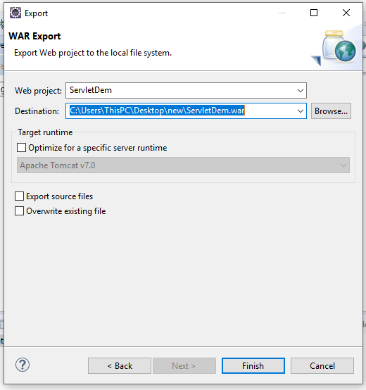

Select the destination location where you want to save the war file.

Then click on finish button.

Go to war location.

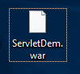

Go to tomcat location where it is installed.

C:\Users\ThisPC\Downloads\apache-tomcat-7.0.107-windows-x64\apache-tomcat-7.0.107\webapps or

C:\Program Files\Apache Software Foundation\Tomcat 10.0\webapps

In that webapps folder paste war file.

Then Start the tomcat Server using double click on startup.bat file

C:\Users\ThisPC\Downloads\apache-tomcat-7.0.107-windows-x64\apache-tomcat-7.0.107\bin\startup.bat

Tomcat will be started.

Then open the browser

<http://localhost:8080/Example/Register.jsp>

press enter

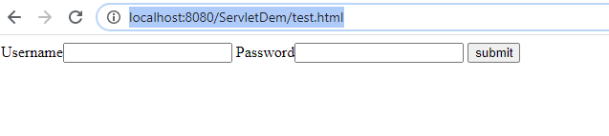

Note-

1. Suppose I have make the changes in any jsp file then next time if you want to deploy the project again then no need to deploy the whole project again.

Just copy that jsp file and paste it into web app folder where your existing file is present.

1. The same thing will be apply for java file also but here you need to copy the .class file.

Right click on Project->Check the workspace location.

Go to that location.

E:\Advanced-Java\ServletTest\build\classes\com\test\TestServlet.class

Copy this class file

Then paste it into tomcat web apps folder as below location.

C:\apache-tomcat-7.0.107-windows-x64\apache-tomcat-7.0.107\webapps\ServletTest\WEB-INF\classes\com\test\TestServlet.class